**Applications of system of linear equation**

Linear equations can be applied in various real-life situations. It can help people to solve many types of real-world problems. The applications here come from economics, chemistry, engineering, and cryptography.

**1. Economics**

Economics is an area that needs lots of applications of linear equations. It can be used to find the market equilibrium (supply = demand). Your demand for a product – a chocolate bar or a car – will depend on the price of the product and how much you earn, among other things. If the product is very expensive, and you’re not that rich, you probably don’t want too much of it. If it’s cheap, like the chocolate bar, you may want a lot. Therefore the demand is often expressed as linear equation. Same as demand, supply is also expressed as linear equation. If the price of the product is higher, the suppliers could gain more profits. As a result, they will produce less when the price of the product decreases and produce more when the price of the product rises. The diagram below shows the demand and the supply lines:

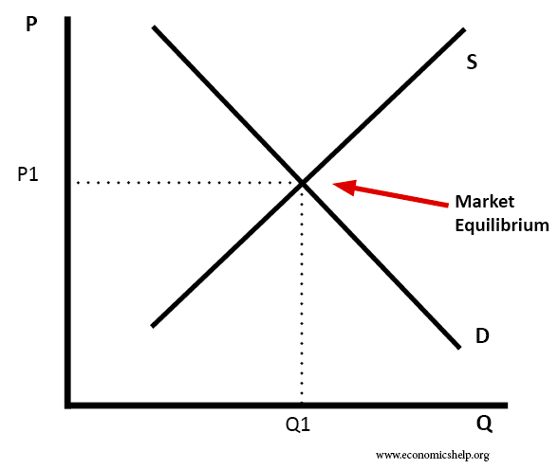

For example, suppose that in a small economy the market demand and supply functions for apples are:

qS = 5p−25

qD = −2p+24

where qD is the quantity of apples demanded (in kg), qS is the quantity of apples supplied (in kg) and p is the price per kilogram of apples (in RM).

This market is in equilibrium when the quantity demanded is equal to the quantity supplied:

qD = qS

As here we are only interested in this market when it is in equilibrium, in order to solve the system of equations we can set both qD and qS equal to q. The demand and supply functions then become:

q = 5p−25 (1)

q = −2p+24 (2)

To find the equilibrium, we need to solve the system of equations (1) and (2) by moving all the unknowns to the left sides of the equations:

$\begin{matrix}q & -5p & = \\ q & +2p & =\end{matrix} \begin{matrix}-25 \\ 24\end{matrix}$ (3)

To look at system (3) as a vector equation:

$$q\left[\begin{matrix}1 \\ 1\end{matrix}\right]+p\left[\begin{matrix}-5 \\ 2\end{matrix}\right]=\left[\begin{matrix}-25 \\ 24\end{matrix}\right]$$

Row reduction of the augmented matrix for the corresponding system of equations shows that:

R1 - R2

R2 / 7

R2 - R1

So the solution of this linear equation is q = 10, p = 7.

We get the solution that this market is in equilibrium when the quantity supply and demand for apples are both 10kg and the equilibrium price of the apples is RM7.

The economists will know the equilibrium price and quantity of a product through solving the equation of the demand and the supply. This is especially helpful in understanding the entire economy’s equilibrium position. It can also help to predict certain consequences of changes in the economic factors.

**2. Balancing Chemical Equations**

The balancing of chemical equations can be made much easier, especially for those who find it difficult, by moving the procedures toward the algorithmic and away from the heuristic. For example, when sodium hydroxide (NaOH) reacts with sulfuric acid (H2SO4) to form sodium sulfate (Na2SO4) and water (H2O). The chemical equation is:

(x1)NaOH + (x2) H2SO4 🡪 (x3) Na2SO4 + (x4)H2O

To “balance” this equation, a chemist must find whole number x1… x4 such that the total number of sodium (Na), oxygen (O), hydrogen (H), and sulfur (S) atoms on the left match the corresponding numbers of atoms on the right (because atoms are neither destroyed nor created in the reaction).

Therefore, we compare the number of sodium (Na), oxygen (O), hydrogen (H), and sulfur (S) atoms of the reactants with the number of the products. Then, we obtain four linear equations:

Na: x1 = 2x3 (1)

O: x1 + 4x2 = 4x3 + x4 (2)

H: x1 + 2x2 = 2x4 (3)

S: x2 = x3 (4)

To solve the system of equation (1), (2), (3), and (4), move all the unknowns to the left sides of the equations.

x1 -2x3 = 0

x1 + 4x2 -4x3 - x4 = 0

x1 + 2x2 - 2x4 = 0

x2 - x3 = 0

Row reduction of the augmented matrix is next.

$$\left[\begin{matrix}1 & 0 & -2 \\ 1 & 4 & -4 \\ \begin{matrix}1 \\ 0\end{matrix} & \begin{matrix}2 \\ 1\end{matrix} & \begin{matrix}0 \\ -1\end{matrix}\end{matrix} \begin{matrix}0 \\ -1 \\ \begin{matrix}-2 \\ 0\end{matrix}\end{matrix} \begin{matrix}\begin{matrix}0 \\ 0\end{matrix} \\ 0 \\ 0\end{matrix}\right]\underset{→}{ }\left[\begin{matrix}1 & 0 & -2 \\ 0 & 4 & -2 \\ \begin{matrix}0 \\ 0\end{matrix} & \begin{matrix}2 \\ 1\end{matrix} & \begin{matrix}2 \\ -1\end{matrix}\end{matrix} \begin{matrix}0 \\ -1 \\ \begin{matrix}-2 \\ 0\end{matrix}\end{matrix} \begin{matrix}\begin{matrix}0 \\ 0\end{matrix} \\ 0 \\ 0\end{matrix}\right]\underset{→}{ }\left[\begin{matrix}1 & 0 & -2 \\ 0 & 1 & -1 \\ \begin{matrix}0 \\ 0\end{matrix} & \begin{matrix}2 \\ 4\end{matrix} & \begin{matrix}2 \\ -2\end{matrix}\end{matrix} \begin{matrix}0 \\ 0 \\ \begin{matrix}-2 \\ -1\end{matrix}\end{matrix} \begin{matrix}\begin{matrix}0 \\ 0\end{matrix} \\ 0 \\ 0\end{matrix}\right]$$

$$\underset{→}{ }\left[\begin{matrix}1 & 0 & -2 \\ 0 & 1 & -1 \\ \begin{matrix}0 \\ 0\end{matrix} & \begin{matrix}0 \\ 0\end{matrix} & \begin{matrix}4 \\ 2\end{matrix}\end{matrix} \begin{matrix}0 \\ 0 \\ \begin{matrix}-2 \\ -1\end{matrix}\end{matrix} \begin{matrix}\begin{matrix}0 \\ 0\end{matrix} \\ 0 \\ 0\end{matrix}\right]\underset{→}{ }\left[\begin{matrix}1 & 0 & -2 \\ 0 & 1 & -1 \\ \begin{matrix}0 \\ 0\end{matrix} & \begin{matrix}0 \\ 0\end{matrix} & \begin{matrix}1 \\ 2\end{matrix}\end{matrix} \begin{matrix}0 \\ 0 \\ \begin{matrix}-1/2 \\ -1\end{matrix}\end{matrix} \begin{matrix}\begin{matrix}0 \\ 0\end{matrix} \\ 0 \\ 0\end{matrix}\right]$$

$$\underset{→}{ }\left[\begin{matrix}1 & 0 & -2 \\ 0 & 1 & -1 \\ \begin{matrix}0 \\ 0\end{matrix} & \begin{matrix}0 \\ 0\end{matrix} & \begin{matrix}1 \\ 0\end{matrix}\end{matrix} \begin{matrix}0 \\ 0 \\ \begin{matrix}-1/2 \\ 0\end{matrix}\end{matrix} \begin{matrix}\begin{matrix}0 \\ 0\end{matrix} \\ 0 \\ 0\end{matrix}\right]\underset{→}{ }\left[\begin{matrix}1 & 0 & 0 \\ 0 & 1 & 0 \\ \begin{matrix}0 \\ 0\end{matrix} & \begin{matrix}0 \\ 0\end{matrix} & \begin{matrix}1 \\ 0\end{matrix}\end{matrix} \begin{matrix}-1 \\ -1/2 \\ \begin{matrix}-1/2 \\ 0\end{matrix}\end{matrix} \begin{matrix}\begin{matrix}0 \\ 0\end{matrix} \\ 0 \\ 0\end{matrix}\right]$$

The general solution is:

R2 + R3

R1 + 2R3

R3 - 2R2

R4 - 2R3

R4 - 4R2

R3 / 4

R3 - R1

R2 - R1

R2 ~ R4

x1 = x4

x2 =x4 /2

x3 = x4 /2

x4 is free

Since the coefficients in a chemical must be integers, take x4 = 2, in which case

x1 = 2

x2 =1

x3 = 1

x4 = 2

The balanced equation is

2NaOH + H2SO4 🡪 Na2SO4 +2H2O

The equation would also be balanced if, for example, each coefficient were doubled. For most purposes, however, chemists prefer to use a balanced equation whose coefficients are the smallest possible whole numbers.

**3. Electrical Networks**

An interesting application of linear equations can be found in electrical engineering and specifically electrical networks. Linear algebra is a useful tool in analyzing electric circuits in terms of organization and saving time.

Current flow in a simple electrical network can be described as a system of linear equations. A voltage source such as a battery forces a current of electrons to flow through the network. When the current passes through a resistor (such as light bulb or motor), some of the voltage is “used up”; by Ohm’s Law, this “voltage drop” across a resistor is given by

V = IR

where the voltage V is measured in volts, the resistance R in ohms (denoted by Ω), and the current flow I in amperes (amps, for short).

According to Kirchhoff’s Laws, all the current flowing into a junction must flow out of it and the sum of the IR terms in any direction around a closed path is equal to the total voltage in the path in that direction.

Figure below shows the example of electrical network:

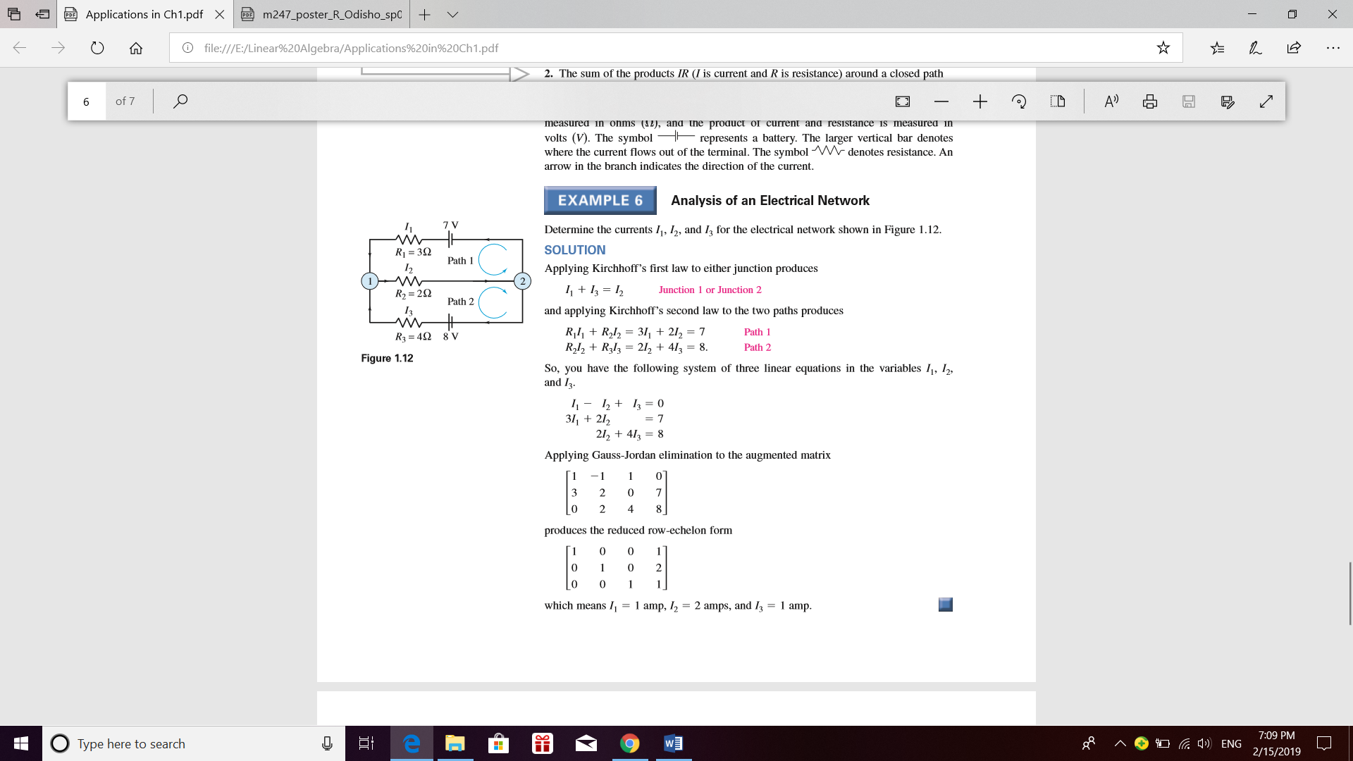

Applying Kirchhoff’s first law to either junction produces

I1 + I3 = I2  (Junction 1 or Junction 2)

and applying Kirchhoff’s second law to the two paths produces

R1I1 + R2I2 = 3I1 + 2I2 = 7 (Path 1)

R2I2 + R3I3 = 2I2 + 4I3 = 8 (Path 2)

So, you have the following system of three linear equations in the variables I1, I2 and I3.

I1 –I2  + I3 = 0

3I1 + 2I2 = 7

2I2 + 4I3 = 8

Row reduction of the augmented matrix for the corresponding system of equations shows that

R1 – 0.4R3

R2 + 0.6R3

R3 / 5.2

R1 + R2

R3 - 2R2

R2 / 5

R2 - 3R1

It leads to the solution: I1 = 1 amp, I2 = 2 amps, and I3 = 1 amp.

**4. Cryptography and Secret Codes**

Cryptography is the discipline of encoding and decoding messages. It is often used for keeping communications private. Encryption is used to keep our data safe on the Internet, or when we use the ATM, and in many other everyday activities. It transforms the data into some unreadable form. Decryption is the inverse of encryption; it is the transformation of encrypted data back into the intelligible form. Both encryption and decryption require the use of some secret information, usually referred as a key. The method that we used to make the encryption more difficult is Hill Chiper.

For example, let the message be

PREPARE*TO*NEGOTIATE

and the key matrix (encoding message) be

$$\left[\begin{matrix}2 & 3 \\ 4 & 5\end{matrix}\right]$$

Then, we assign each character with a number which shown as below:

|  |  |  |  |  |  |  |  |  |  |  |  |  |  |  |  |  |  |  |  |
| --- | --- | --- | --- | --- | --- | --- | --- | --- | --- | --- | --- | --- | --- | --- | --- | --- | --- | --- | --- |
| A | B | C | D | E | F | G | H | I | J | K | L | M | N | O | P | Q | R | S | T |
| 0 | 1 | 2 | 3 | 4 | 5 | 6 | 7 | 8 | 9 | 10 | 11 | 12 | 13 | 14 | 15 | 16 | 17 | 18 | 19 |
| U | V | W | X | Y | Z | * |
| 20 | 21 | 22 | 23 | 24 | 25 | 26 |

Our alphabet size (m) = 27

We convert it to its numerical equivalent and it up into row vectors of length two.

15 17 | 4 15 | 0 17 | 4 26 | 19 14 | 26 13 | 4 6 | 14 19 | 8 0 | 19 4

To encrypt the message, we will take the transpose of each vector and premultiply by A in order to apply the linear transformation.

$$\left[\begin{matrix}2 & 3 \\ 4 & 5\end{matrix}\right]\left[\begin{matrix}15 \\ 17\end{matrix}\right]= \left[\begin{matrix}81 \\ 145\end{matrix}\right]$$

$$\left[\begin{matrix}2 & 3 \\ 4 & 5\end{matrix}\right]\left[\begin{matrix}4 \\ 15\end{matrix}\right]= \left[\begin{matrix}53 \\ 91\end{matrix}\right]$$

$$⋮$$

This will give us the numerical message.

81 145 | 53 91 | 51 85 | 86 146 | 80 146 | 91 169 | 26 46 | 85 151 | 21 41 | 50 96

As these numbers don't appear to correspond to any of the letters in our table, we need to take all of the values modulo 28 in order to get numbers that correspond to our starting alphabet.

0 10 | 26 10 | 24 4 | 5 11 | 26 11 | 10 7 | 26 19 | 4 16 | 21 14 | 23 15

Therefore, our message will be sent in form of “AJZJXDEKZKJGZSDPUNWN”.